SOCIAL STUDIES TOOLKIT 2025-2026



PRESENTED BY:
THE HHS SOCIAL STUDIES DEPARTMENT

Introduction: As we examine the vocations of people from all walks of life, we know certain reliable tools are needed to help get the job done. It is very difficult for the painter to complete a task without paint and a paint brush, sprayer or roller. As you embark on your social studies courses, there are certain apparatuses that you will need to successfully navigate through the prescribed curriculum. The purpose of unit “0” is to provide students and teachers with some of the instruments that will be optimize your learning experience in these classes.
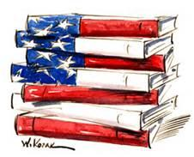

We will begin learning about the following:
- Political Cartoon Analysis
- Photograph Analysis
- Drawing Conclusions, and summarization
- Chart and graph analysis

A political cartoon, a drawing (often including caricature) made for the purpose of conveying editorial commentary on politics, politicians, and current events. Such cartoons play a role in the political discourse of a society that provides for freedom of speech and of the press. These visuals have been important in history by informing illiterate citizens and conveying a point of view on a political issue. Cartoonists, with a single picture, could insult enemies, celebrate allies, change people’s minds on important issues, and be humorous enough to make an impact on the public’s view. Political cartoons bring humor and exaggeration to past and current issues. In substance, political cartoons are pictures with a point. The points below can assist you in your efforts to effectively analyze political cartoons:

- Caricature- a picture, description, or imitation of a person in which certain striking characteristics are exaggerated in order to create a comic or grotesque effect.
- Symbolism - Simple objects, or symbols, can stand for larger concepts or ideas.
- Exaggeration - Physical characteristics of people or things may be exaggerated to make a point.
- Labeling - Sometimes objects or people are labeled to make it obvious what they stand for.
- Analogy - By comparing two different things, cartoonists can help their readers see a different point of view. If students discover an analogy, have them decide what the analogy is comparing and the point the comparison makes.
- Irony - Irony is the difference between the way things are and the way things should be or are expected to be. Students should decide if the irony expresses an opinion on the issue.

ACTIVITY #1: Analyze the political cartoon and answer the questions that follow. As you analyze the image please refer to the terms on the previous page to assist you in breaking down the message of the political cartoon.
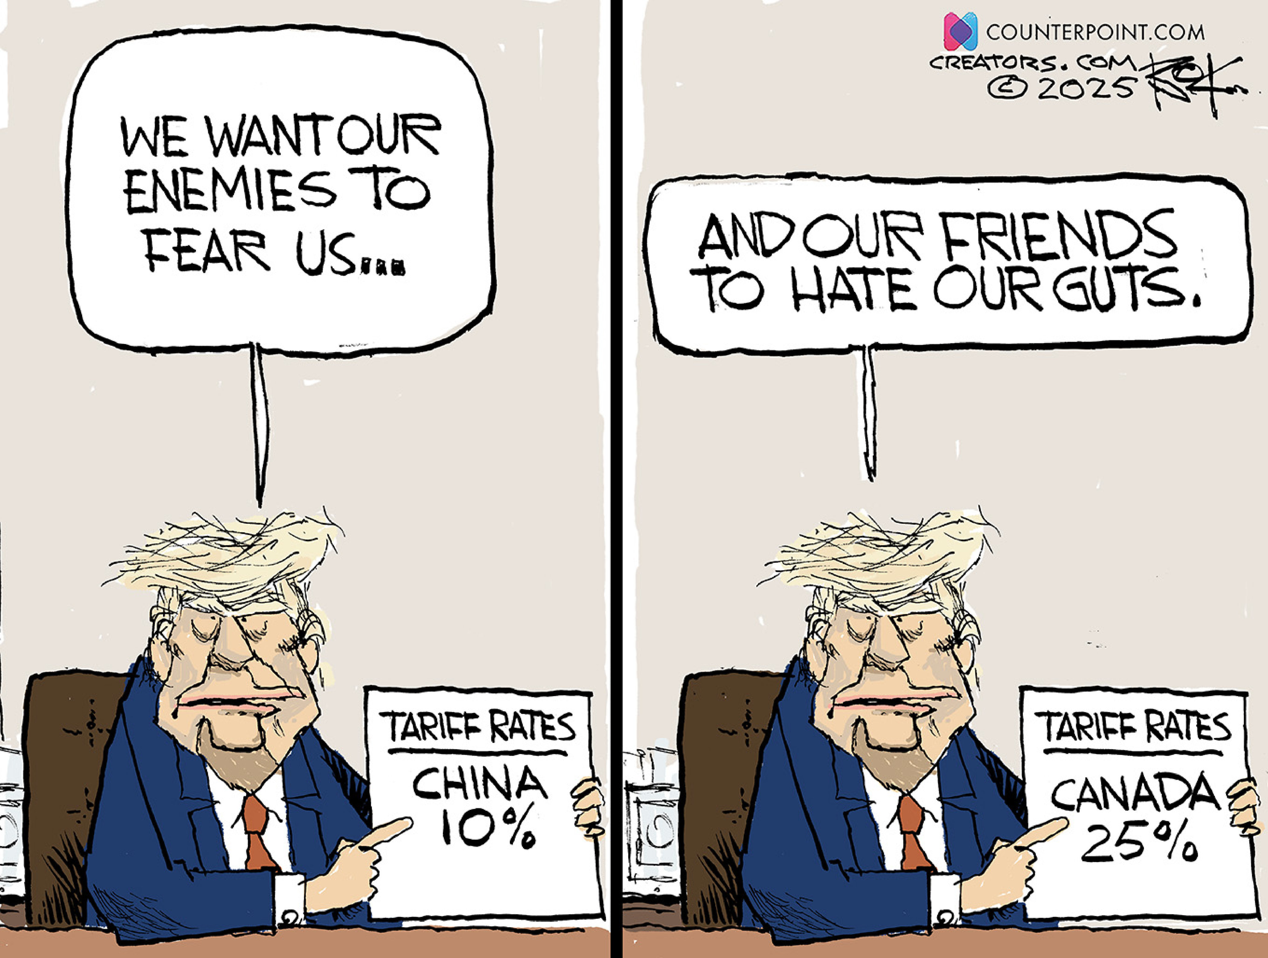

- Identify and describe the “character” in this political cartoon.
- Please give details about what is occurring in this image. What does the image mean?
- Regardless of your personal political preferences, explain how this picture describes recent historical events that will affect the American people.
There is an old cliché that states that a picture is worth a thousand words. As we learn about social studies, pictures often serve as powerful primary source documents. It is imperative that teachers and students take to the time to carefully examine historical pictures with purpose of understanding the context of the image in question, and what that picture says about the period of study in question.
Activity #2: Please analyze the image and complete the accompanying chart.
IMAGE | INSTANT THOUGHTS | INQUIRY | INFRENCE
 | (List key words you associate with this image) | (What questions does this photograph raise in your mind?) | (Based on what you have observed, what are some things you can infer from this photograph.)

Historical speeches are also primary source documents. On April 4,1967 Martin Luther King, Jr., delivered his seminal speech at Riverside Church condemning the Vietnam War.
Activity #3: Please read and analyze the excerpt below and answer the question in the box below the excerpt.
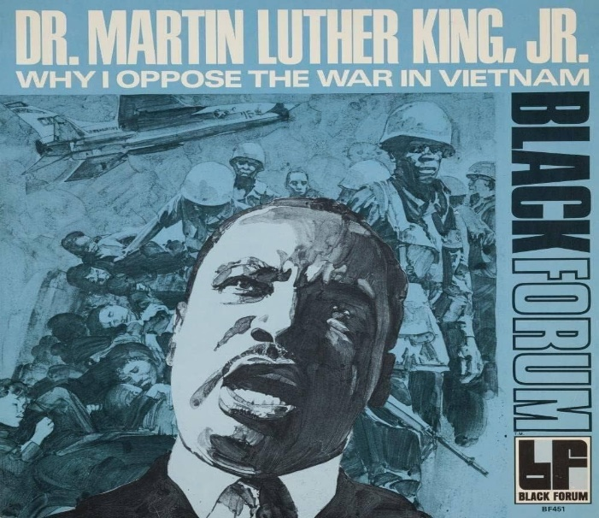 | A few years ago, there was a shining moment in that struggle. It seemed as if there was a real promise of hope for the poor — both black and white — through the poverty program. There were experiments, hopes, new beginnings. Then came the buildup in Vietnam, and I watched this program broken and eviscerated, as if it were some idle political plaything of a society gone mad on war, and I knew that America would never invest the necessary funds or energies in rehabilitation of its poor so long as adventures like Vietnam continued to draw men and skills and money like some demonic destructive suction tube. So, I was increasingly compelled to see the war as an enemy of the poor and to attack it as such.

- After reading the excerpt, what can you infer regarding Dr. King’s primary reason for opposing the Vietnam War. Please support your response with evidence from the text.

Charts and graph are vital tools that often make understanding social studies content easier.
Activity #4: Please read and analyze the chart that compares and contrasts the resources of the north and south during the American Civil War Era. Please complete the questions in the chart.
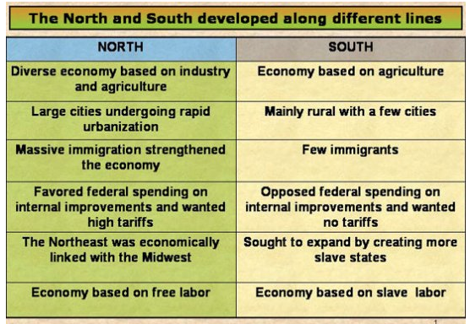 | - How could the diversity of north’s economy serve as an advantage to the Union during the American Civil War?  - While the economy of the south was based on agriculture, the north actually produced more food than the Confederate states. Explain how this is possible.

